Calculus Based Physics 1: LAB
PHYS 2110 WA
Date: June 15, 2023
Isaac Abella

Experiment 5: Charging of a Capacitor

Groups:
Isaac Abella
Objective:
The objective of this lab is to verify the exponential behavior of capacitors during charging.

Equipment:
A computer with internet connection, paper, pencil, and a calculator (ti-84 plus CE/ti 30sx II)\

Theory:
A capacitor is a passive electric device that stores electric energy. A parallel plates capacitor is made of two parallel metallic surfaces, each of an area A, separated by an insulation layer of thickness d, and has a capacity that can be expressed as:
Capacity C is the capacity of a capacitor in Farads, A is the area of each plate in m², and the insulation (dielectric) thickness is in m, and the ε₀ is the permittivity of free space, the vacuum between plates for electric field propagation. This is expressed as F/m (Farads/meter)

K, or Kappa, denotes the dielectric constant, and that depends on the material that is used as the insulation layer. Capacitance C does not depend on the material of the plates. ε_{0,} the dielectric constant, is related by Coulomb’s constant K.
In the circuit loop above of a parallel plates capacitor, when the key is turned on, then electrons begin to flow from the negative flow of the battery to the lower plates, and protons flow from the positive pole of the battery towards to upper plate. The bottom plate becomes negatively charged and the upper plate will become positively charge.

However, this process does not happen in an instant, but rather over time. The current is maximum to begin with, and will decreases as the charges begin to accumulate on the plates. At the start, when the key is just switched on, the capacity on each of the plates is empty; therefore, the voltage across capacitor V_{c} approaches the battery voltage V_{bat.}

During this charging and discharging phase, the voltage across the capacitor and the current through it follows the following exponential equations:

(Charging)  Battery in Circuit | 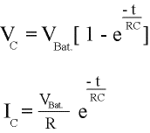 | At t = 0,  VC = 0  IC = VB/ R | As t → ∞  VC = VBat.  IC = 0
(Discharging)  With battery removed, the initial capacitor voltage is Vo= Qo/C making the initial current Io = Vo/R | 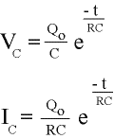 | At t = 0,  VC = Qo /C  IC = Qo/(RC) | As t → ∞  VC = 0  IC = 0

When calculating the values of charging and discharging capacitors, it’s a good idea to set t = 0 or t = ∞ depending on equation needed. Then observe the comparison of the Current and Voltage graphs for charging and discharging capacitors.

Procedure:

After being loaded into the virtual lab, the case experiments were configured. The battery voltage, resistor, and parallel capacitance were adjusted to meet each case.
After the Tau for each case (Resistance * Capacitance) was calculated, the charging duration was then determined by multiplying it by factors of 5 (measured in seconds), and the data recording interval was found by dividing it by 10 (measured in seconds).
The data for each case was recorded and then verified through the charging/discharging exponential equations, and then summed up and compared to the total battery voltage to observe any changes in the voltage threshold.
Graphs were then created to visualize the relation between Ic and Vc over time. These graphs were compared to the theory section graphs and earlier course material to verify the objective.
Graphs:
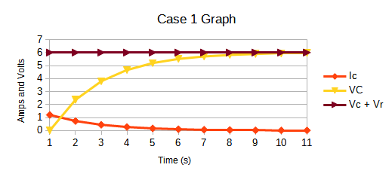
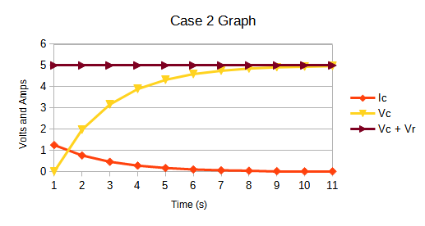
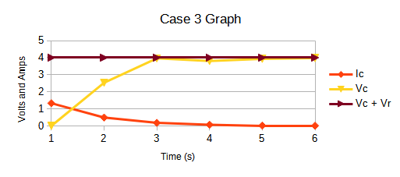
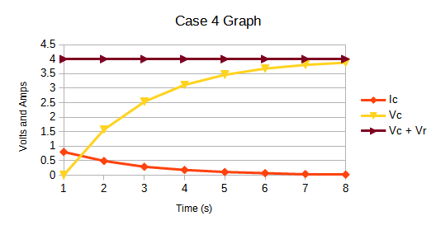
Data:

Given:
V_{o}C – The initial capacitor voltage (0 for all cases)
Measured:
The duration of charging varies from case to case

Below are data tables of all 4 cases and their graphs condense to a page.

Case 1: | 0 | 5 | 10 | 15 | 20 | 25 | 30 | 35 | 40 | 45 | 50
Ic | 1.2 | 0.73 | 0.44 | 0.27 | 0.16 | 0.1 | 0.06 | 0.04 | 0.02 | 0.01 | 0.01
VC | 0 | 2.36 | 3.79 | 4.66 | 5.19 | 5.51 | 5.7 | 5.82 | 5.89 | 5.93 | 5.96
Vr | 6 | 3.64 | 2.21 | 1.34 | 0.81 | 0.49 | 0.3 | 0.18 | 0.11 | 0.07 | 0.04
Vc + Vr | 6 | 6 | 6 | 6 | 6 | 6 | 6 | 6 | 6 | 6 | 6

Case 2: | 0 | 4 | 8 | 12 | 16 | 20 | 24 | 28 | 32 | 36 | 40
Ic | 1.25 | 0.76 | 0.46 | 0.28 | 0.17 | 0.1 | 0.06 | 0.04 | 0.02 | 0.01 | 0.01
Vc | 0 | 1.97 | 3.16 | 3.89 | 4.32 | 4.59 | 4.75 | 4.85 | 4.91 | 4.94 | 4.97
Vr | 5 | 3.03 | 1.84 | 1.11 | 0.68 | 0.41 | 0.25 | 0.15 | 0.09 | 0.06 | 0.03
Vc + Vr | 5 | 5 | 5 | 5 | 5 | 5 | 5 | 5 | 5 | 5 | 5

Case 3: | 0 | 6 | 12 | 18 | 24 | 30
Ic | 1.33 | 0.49 | 0.18 | 0.07 | 0.02 | 0.01
Vc | 0 | 2.53 | 3.96 | 3.8 | 3.93 | 3.97
Vr | 4 | 1.47 | 0.54 | 0.2 | 0.07 | 0.03
Vc + Vr | 4 | 4 | 4 | 4 | 4 | 4

Case 4: | 0 | 7.5 | 15 | 22.5 | 30 | 37.5 | 45 | 52.5 | 60 | 67.5 | 75
Ic | 0.8 | 0.49 | 0.29 | 0.18 | 0.11 | 0.07 | 0.04 | 0.02 | 0.01 | 0.01 | 0.01
Vc | 0 | 1.57 | 2.53 | 3.11 | 3.46 | 3.67 | 3.8 | 3.88 | 3.93 | 3.96 | 3.97
Vr | 4 | 2.43 | 1.47 | 0.89 | 0.54 | 0.33 | 0.2 | 0.12 | 0.07 | 0.04 | 0.03
Vc + Vr | 4 | 4 | 4 | 4 | 4 | 4 | 4 | 4 | 4 | 4 | 4

Calculations:
While all the values were collected inside the virtual laboratory, we can verify each of these values using the experiential formulas located in the theory section of the lab manual.

Case 2 Calculation Sample:
Given: Vbat = 5.00 Volts, Resistance = 4.00Ω, and C = 2.00 Farads.
τ = RC => 4.00×2.00 = 8.00 seconds.
Charging duration = 8.00×5 = 40.00 seconds
Data Recording Intervals = 40.00/10.00 = 4 seconds

To calculate I_{c} and V_{c:}

VC:
0 seconds = Vbat * [1-e^-t/RC] => 5.00 * [1-e^-0/8] = 0 Volts
4 seconds = Vbat * [1-e^-t/RC] => 5.00 * [1-e^-4/8] = 1.96 Volts
8 seconds = Vbat * [1-e^-t/RC] => 5.00 * [1-e^-8/8] = 3.16 Volts
12 seconds = Vbat * [1-e^-t/RC] => 5.00 * [1-e^-12/8] = 3.84 Volts
16 seconds = Vbat * [1-e^-t/RC] => 5.00 * [1-e^-16/8] = 4.32 Volts
20 seconds = Vbat * [1-e^-t/RC] => 5.00 * [1-e^-20/8] = 4.58 Volts
24 seconds = Vbat * [1-e^-t/RC] => 5.00 * [1-e^-24/8] = 4.75 Volts
28 seconds = Vbat * [1-e^-t/RC] => 5.00 * [1-e^-28/8] = 4.84 Volts
32 seconds = Vbat * [1-e^-t/RC] => 5.00 * [1-e^-32/8] = 4.91 Volts
36 seconds = Vbat * [1-e^-t/RC] => 5.00 * [1-e^-36/8] = 4.94 Volts
40 seconds = Vbat * [1-e^-t/RC] => 5.00 * [1-e^-40/8] = 4.97 Volts

IC:
0 Seconds = Vbat/R * e^-t/RC => 5.00V/4.00Ω * [e^-0/8] = 1.25 Volts
4 Seconds = Vbat/R * e^-t/RC => 5.00V/4.00Ω * [e^-4/8] = 0.758 Volts
8 Seconds = Vbat/R * e^-t/RC => 5.00V/4.00Ω * [e^-8/8] = 0.459 Volts
12 Seconds = Vbat/R * e^-t/RC => 5.00V/4.00Ω * [e^-12/8] = 0.279 Volts
16 Seconds = Vbat/R * e^-t/RC => 5.00V/4.00Ω * [e^-16/8] = 0.169 Volts
20 Seconds = Vbat/R * e^-t/RC => 5.00V/4.00Ω * [e^-20/8] = 0.103 Volts
24 Seconds = Vbat/R * e^-t/RC => 5.00V/4.00Ω * [e^-24/8] = 0.062 Volts
28 Seconds = Vbat/R * e^-t/RC => 5.00V/4.00Ω * [e^-28/8] = 0.038 Volts
32 Seconds = Vbat/R * e^-t/RC => 5.00V/4.00Ω * [e^-32/8] = 0.023 Volts
36 Seconds = Vbat/R * e^-t/RC => 5.00V/4.00Ω * [e^-36/8] = 0.013 Volts
40 Seconds = Vbat/R * e^-t/RC => 5.00V/4.00Ω * [e^-40/8] = 0.008 Volts

Comparison of Results:
The lab conducted showed the relation of a capacitor undergoing a charging phase and the relationship between the current and the voltage through the circuit over time.

The lab manual’s example of a charging capacitor shows two exponential graphs, the relationship of Ic over time is a decaying, while the relationship of Vc over time is a growth before flatting out at the max battery voltage.
Conclusion:
The objective of this lab was to verify the exponential behavior of capacitors during the charging. When observing the graphs gathered through case data and comparing them back to the theory portion of the lab manual and course chapter 27 + 28, we can see that there is exponential behavior in capacitors.

We can see that as the Voltage V_{c} increases and reaches the max voltage of the battery, the current I_{C} decreases in the resistor. This causes Vr to go 0. We can also confirm this relationship by looking at the tau at 0 and the charge at 0. When the tau is at 0, the voltage charge is also at 0 for all 4 cases.

Discussion:
For this lab, it is still possible that human error influenced the outcome of final observations of the case graphs. One case could be that the conductor had not properly measured and recorded data at the right time intervals, which can cause the data to be off slightly. Other ways that the data in the lab could go against the objective/theory would be that the data was inputted incorrectly into the graph software, which can cause the entire graph to come out wrong.

Overall though, the chance for human error in this lab were very easy to mitigate through observing and double checking values at each step, and then verifying the virtual software by using exponential equations.

